Question
Develop a C program using fork() that creates a parent and child process.Display the process ID(PID), Parent Process ID(PIP), and process states at different stages of execution.

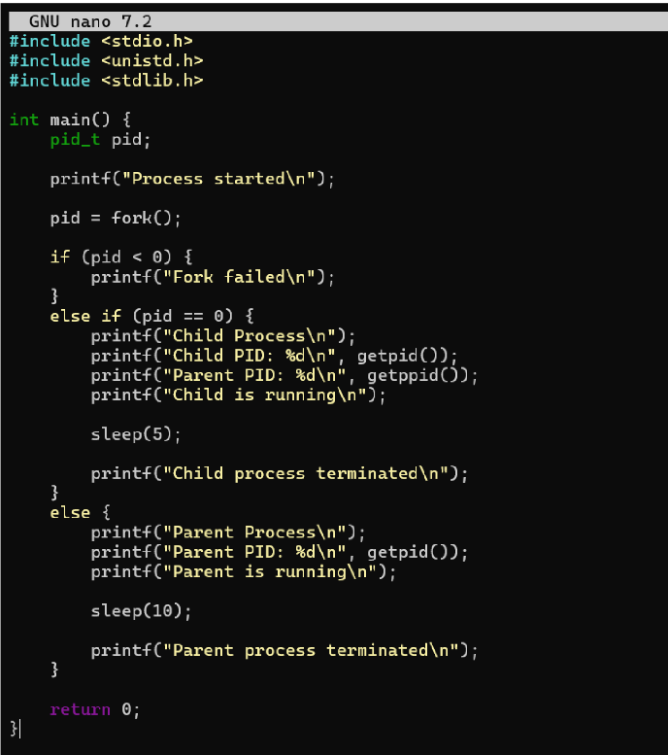
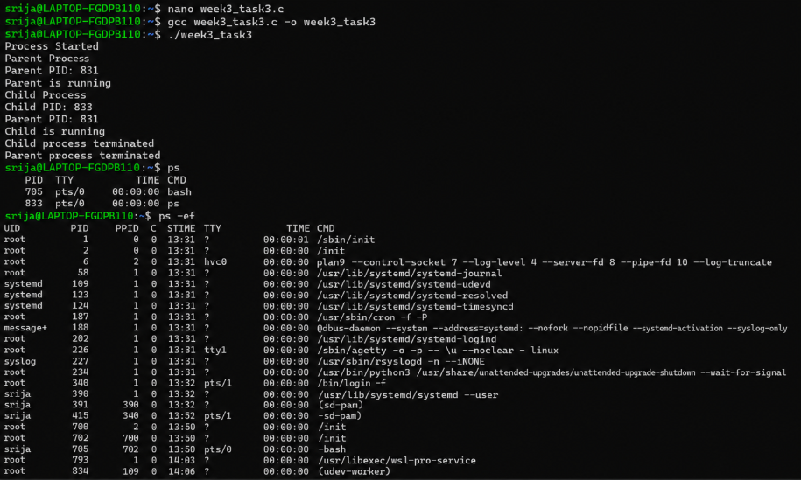
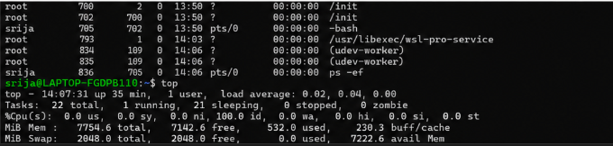
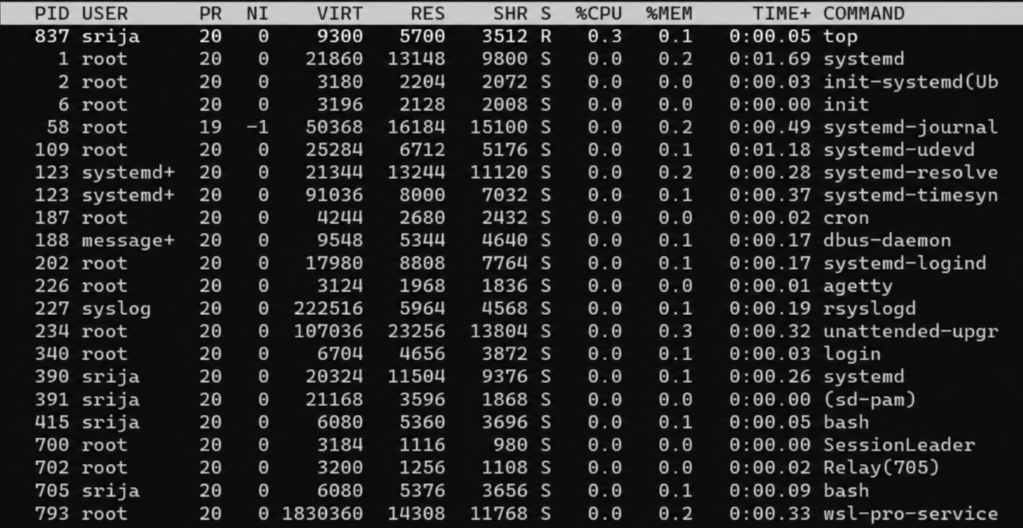
The fork() system call is used to create a new process. The original process is called the parent process, and the newly created process Is called the child process.Each process has its own PID, and the child process can get its parent’s ID using PPID. During execution, processes move through different states such as running, waiting, and terminated.

